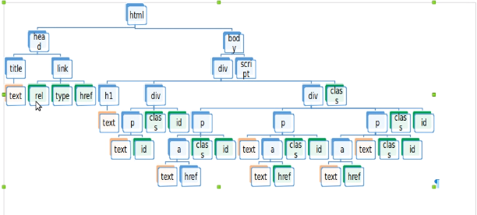

<a>

<a>

<a>

<html>

<p>

<p>

<p>

<div>

<p>

<h1>

<div>

<script>

<body>

<div>

<link>

<title>

document

<head>